IPL Cricket Data Analysis and Visualization Report

Prepared by

Anil Joshi (4)

Kapil Tripathi (26)

Akash Kumar Besra (3)

Rohit Kumar Bhagat (39)

Basant Tirkey (15)

Submitted to

Vikas Pandey

Title: IPL Cricket Data Analysis and Visualization Report

**Introduction**:

In this report, we present an analysis and visualization of IPL cricket data. The dataset used for this analysis contains comprehensive information about IPL matches, teams and various performance metrics from previous seasons. Our objective is to gain insights team performances, identify trends, and present the findings through informative visualizations.

**Data Source**:

The dataset used for this analysis was collected from official IPL records.

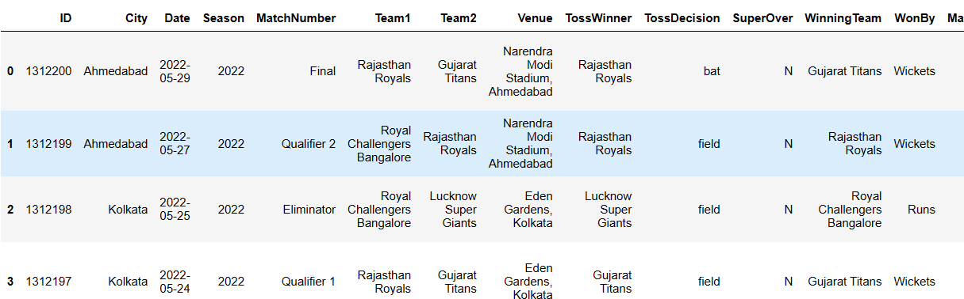

**About project**:  
 The dataset which we have used is based on the ipl data from 2008 to 2022 .Some import highlight of this project.  
  
**Library used are :**

* Numpy

*Pandas

*Seaborn

*Matplotlib

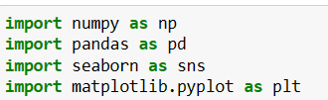

**Overall code flow :**

Reading of dataset:



Analysis of dataset:

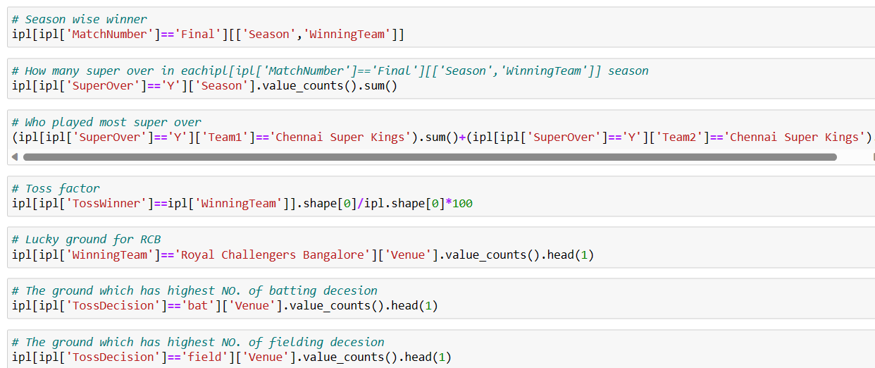

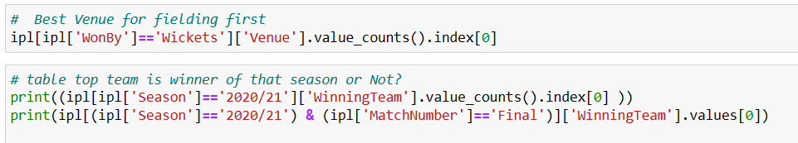

Visualizations:

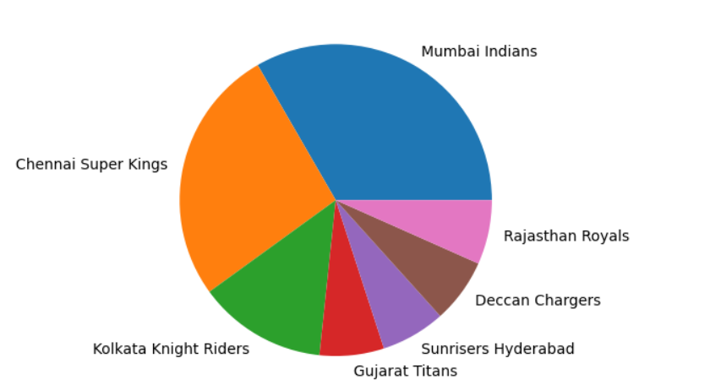

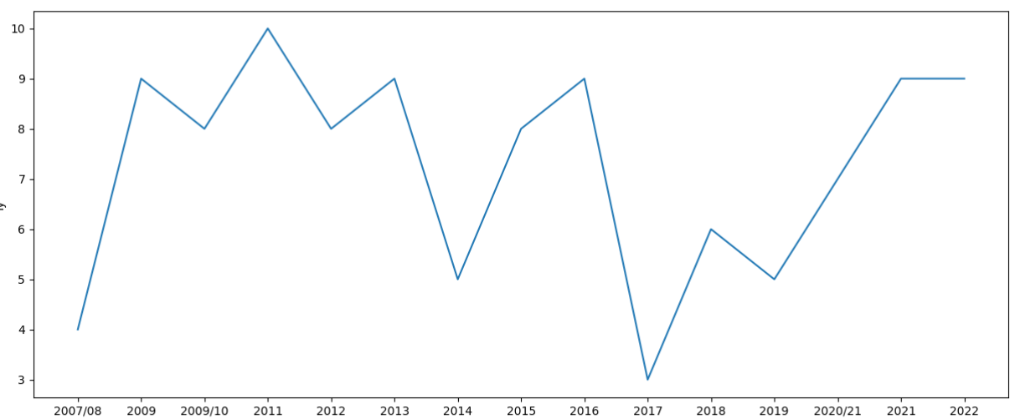

**Analysis and Visualizations**:

1. **Trends Analysis with visualizations**:

**Match Results Over the Years**: A pie chart depicting the trend of match results over different IPL seasons. This visualization allows us to observe any patterns in team performance over time.

**Code:**

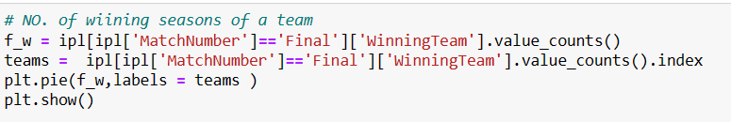

**Visualizations :**

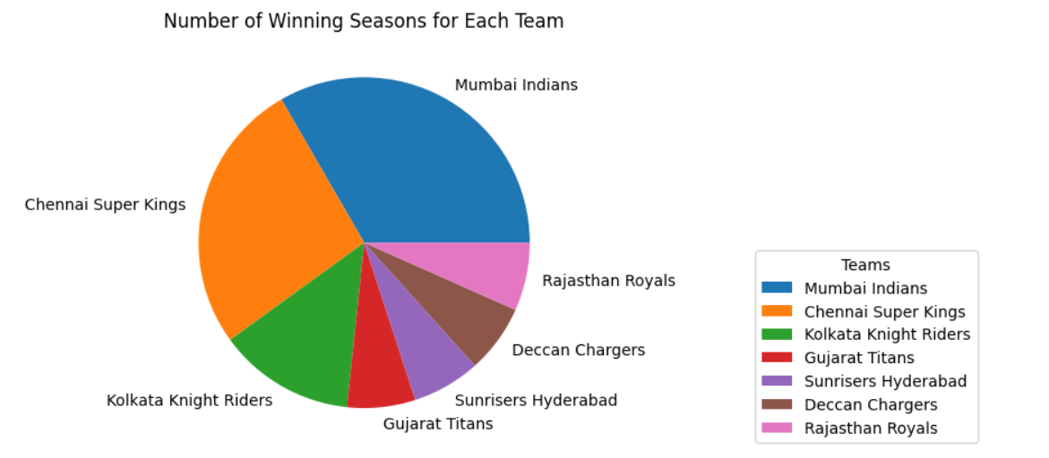

**Season wise performance of RCB:**

A line chart telling about the performance of RCB season wise .

**Code :**

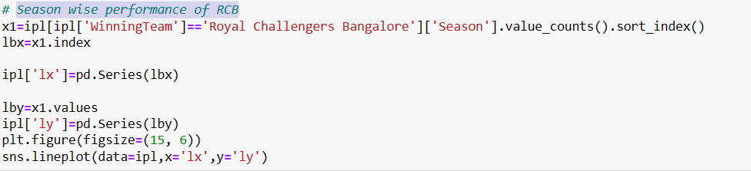

**Visualizations :**

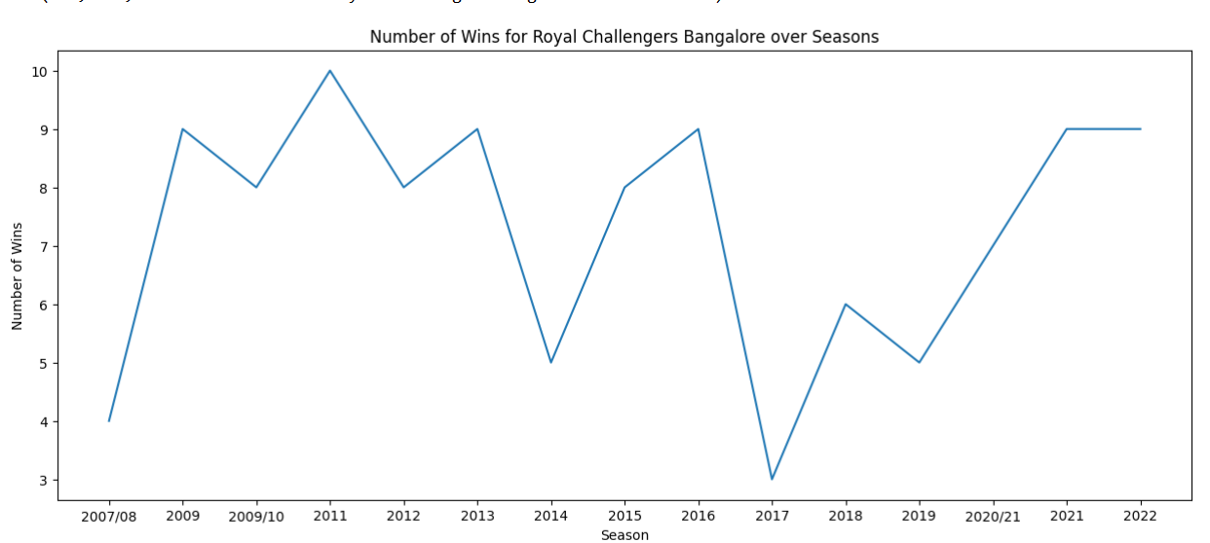

Conclusion:

Through our data analysis and visualizations, we have gained valuable insights into IPL cricket. We identified the most successful teams examined the trends in match results, and explored the impact of toss and home advantage. These findings can be used by team management, players, and cricket enthusiasts to make informed decisions and gain a deeper understanding of IPL dynamics.